**Play with Watercolor** *(studio-based)*

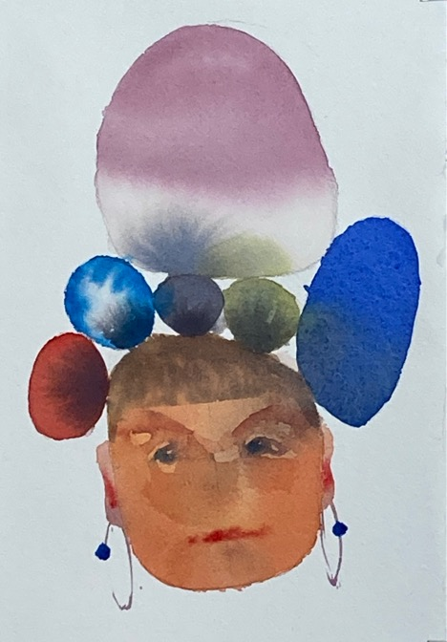 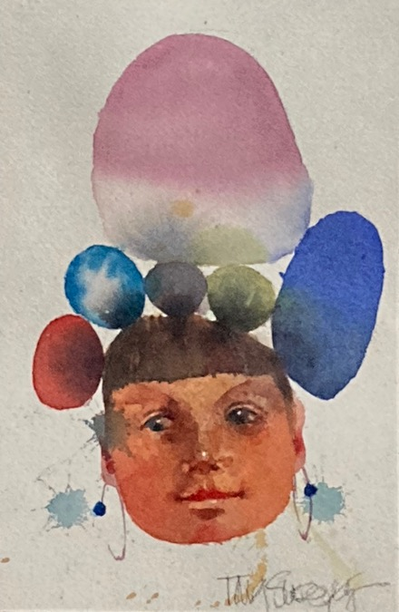

In this workshop full of playful, connected, flow, spontaneity makes for great fun whether you are a complete beginner or an experienced painter looking to revitalize your technique. Follow watercolor’s lead with a split primary limited palette: jump start your creativity with a variety of intuitive starting points; wake up your senses; strengthen your technique; paint what makes your heart sing. Build confidence as you explore pigment characteristics, wet-into-wet mingling, transparent layering, intentional lost and found edges, and lively brushwork with instructor demos, guided exercises and individualized feedback. All levels are welcome.

*2 to 3-day workshop (12 to 18 hours contact hours)*

*Ideal enrollment: 15*

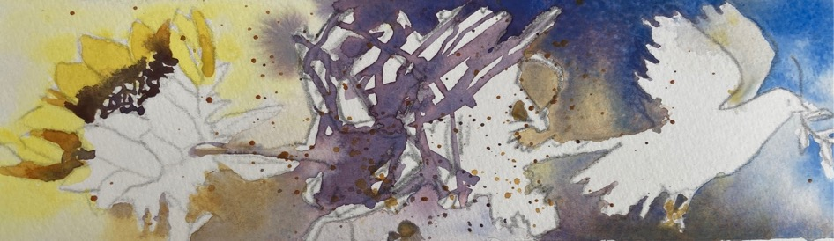

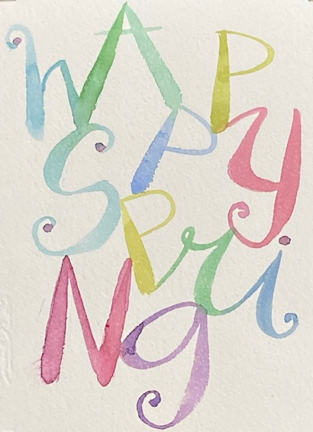 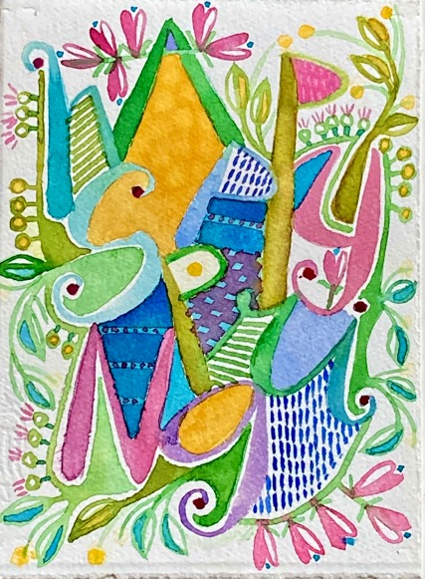

**Materials List for Play With Watercolor:**

-PROFESSIONAL QUALITY 140# cold press watercolor paper and mounting board, OR watercolor BLOCK, 140# cold press. Minimum size: 9x12 inches; maximum size 12x18, quarter sheet (11x15) or similar is fine.

-PROFESSIONAL QUALITY tube pigments. Bring what you already have but be sure to have a minimum of a warm and a cool temperature hue for each primary, and a neutral gray. For example: quinacridone gold (warm); hansa yellow (cool); napthol red (warm); quinacridone rose (cool); phthalocyanine blue green shade (cool); ultramarine blue (warm); and paynes gray.

-ADDITIONAL supplies:

* palette with good-sized mixing wells
* good quality watercolor round brush #10. It should make a really wet, juicy mark when fully loaded as well as a fine line when just the tip is loaded.
* 3 rinsing containers
* permanent black ink pen--instructor uses a fountain pen or Staedtler pigment liner .3-.5
* Speedball dip pen with classic pointed drawing nib (for use with watercolor, not ink)
* Signo Uni-ball white pen or white gouache
* paper towels or an absorbent rag
* sketchbook for working out ideas
* drawing pencil , 2B to 6B range
* kneaded eraser
* pencil sharpener
* tracing paper and graphite transfer paper

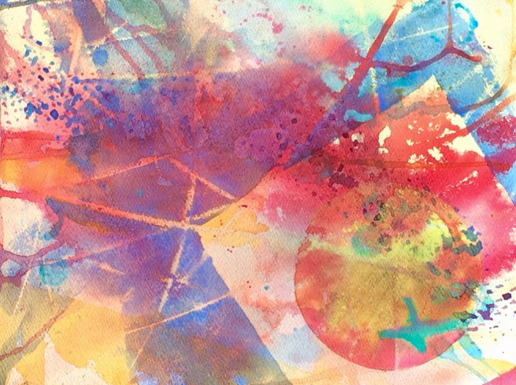**Teaching Philosophy**

I have been painting for nearly forty years and I am not yet bored with watercolor. I like to think of our partnership like a dance--when I remember to follow its strong lead, the result is fluid, elegant, effortless. When I don’t, we still dance, but it’s awkward. Learning to follow watercolor’s lead takes time, good coaching, and a willingness to try and try again. That’s where I can help.

What kind of watercolor are you longing to paint? The “right” way to paint is the way that best supports your ideas and goals (not mine). With more than thirty years of teaching experience I can help you explore *what* to paint and *how,* but just as importantly, *why* you want to paint. We’ll identify creative goals and explore solid techniques and design to support your progress. When you get stuck—every painter struggles with this –I’ll help you find ways to get going again. We’ll look at your painting in progress to see where you are succeeding. When you want direction, I’ll be there to suggest what might come next. My daily step-by-step workshop demonstrations and warmup exercises are carefully designed to support your progress. I provide a written summary and visual aids so you can see, hear and review content. For each workshop, I check my previous content for fit, and revise as needed. This insures content is fresh for me as well as repeat participants.

We’ll start wherever you are in your creative journey. Together we will make art *and* messes, intentional choices *and* happy accidents. We will find problems to solve, courage to try, and resilience to continue. You’ll learn how you want to paint, but more importantly, why.

I look forward to learning what you long to create, what might be holding you back, and how I can help you acquire the skills and confidence to bring your best paintings to life. At the end of our time together, I’ll know I’ve succeeded when your work is distinctively yours, (not at all like mine), and you can’t wait to do more.

**Tara**