**Watercolor Figures** *(studio and plein air)*

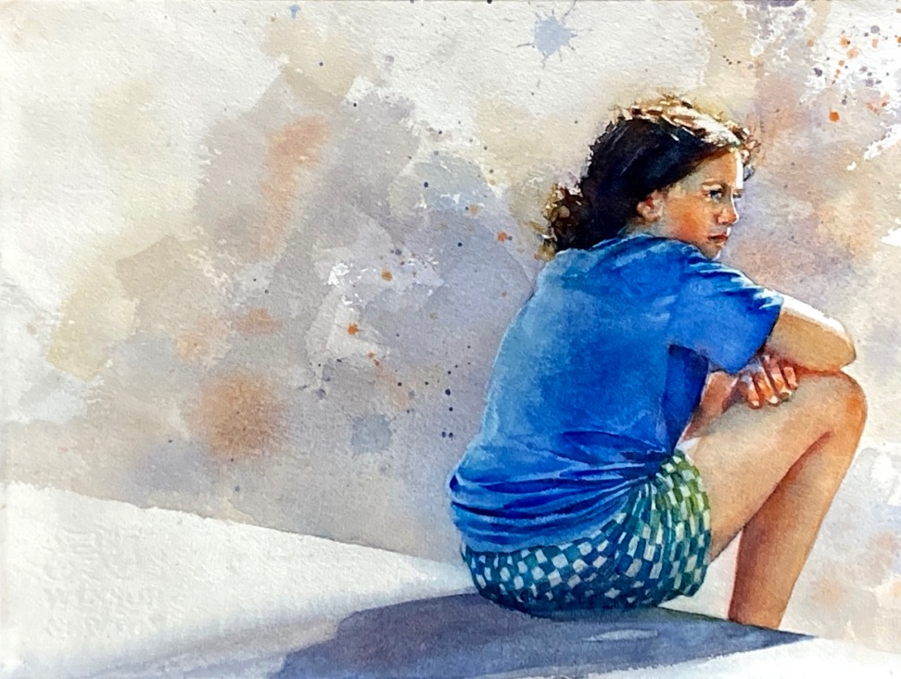

Expand your watercolor toolbox with figures. Work from photo reference and direct observation to animate your compositions. Explore adding figures where you want them to be. Learn to see the structure of light and shadow, perspective, and depth as you simplify figures and spaces into shapes and values with a three-layer/four-value approach to watercolor. Build confidence as you explore pigment characteristics, wet-into-wet mingling, transparent layering, intentional lost and found edges, and lively brushwork with instructor demos, guided exercises and individualized feedback. All levels are welcome.

*4- to 5-day workshop (24 to 30 contact hours)*

*Ideal enrollment: 15*

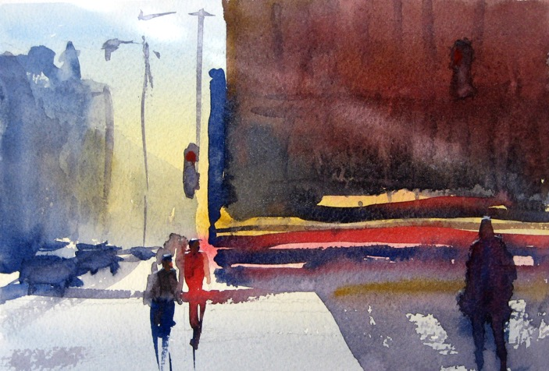**Materials List**

-PROFESSIONAL QUALITY PAPER: Minimum size of 9x12 inches professional quality watercolor BLOCK, or quarter sheet paper 11 x 15 inches and surface to mount it on. You are welcome to work larger if you wish but generally the quarter sheet size is a good starting point. I use Arches or Winsor Newton 140# cold press.

-PROFESSIONAL QUALITY TUBE WATERCOLORS: no hard pan cakes please. I use M. Graham, Daniel Smith and QoR watercolors. If you already have professional quality tube colors, use what you have. At a minimum, have a split primary limited palette of at least 2 yellows, 2 blues, two reds, and paynes gray. Split primaries lean in different temperature directions. For example, pthalo blue leans toward yellow (it’s a green-blue) while ultramarine leans toward red (it’s a violet blue). A sample palette: quinacridone nickel gold; hansa yellow; quinacridone rose, napthol or pyrrol red, pthalo blue; ultramarine blue, as well as paynes gray for value studies.

-PALETTE: must be a good-sized tray for laying out tube colors AND good-sized mixing areas. I use Jones Travel round with space for colors in the base and four divided mixing wells in the lid.

-BRUSHES: I primarily use three brushes: Silver Black Velvet jumbo round small mop or a squirrel mop for wet-into-wet first layer washes; a #10-12 sable or pseudo sable watercolor round for middle layer washes; and a springy synthetic #10 watercolor round for controlled third layer dry brush and fine details. At a minimum, bring these three brushes or equivalent shapes, sizes and quality to deliver the same load. Occasionally, I use some of these tools: medium or large squirrel mops; one-inch or two-inch squares; #6-#8 sable rounds; eye dropper; fountain pen with permanent black ink. They are optional. Bring them if you have them on hand.

-OTHER SUPPLIES:

2B-6B drawing pencil and hand sharpener

-kneaded eraser

-3 rinsing containers

-small spray bottle

-small household sponge or absorbent rag

-tracing paper

-graphite transfer paper

-NEUTRAL PH artist tape. NO bright blue painter’s masking tape please.

-table easel or a way to prop up your block or support at an angle to paint

-PHOTO REFERENCE *and guidelines for preparing a drawing will be emailed to registered participants one week or more beforehand.*

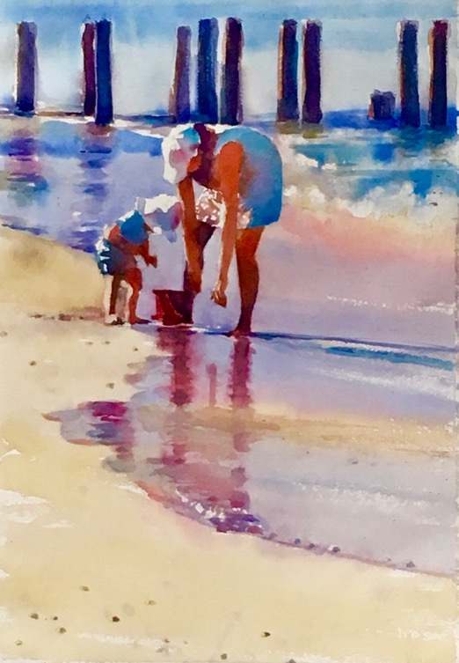**Teaching Philosophy**

I have been painting for nearly forty years and I am not yet bored with watercolor. I like to think of our partnership like a dance--when I remember to follow its strong lead, the result is fluid, elegant, effortless. When I don’t, we still dance, but it’s awkward. Learning to follow watercolor’s lead takes time, good coaching, and a willingness to try and try again. That’s where I can help.

What kind of watercolor are you longing to paint? The “right” way to paint is the way that best supports your ideas and goals (not mine). With more than thirty years of teaching experience I can help you explore *what* to paint and *how,* but just as importantly, *why* you want to paint. We’ll identify creative goals and explore solid techniques and design to support your progress. When you get stuck—every painter struggles with this –I’ll help you find ways to get going again. We’ll look at your painting in progress to see where you are succeeding. When you want direction, I’ll be there to suggest what might come next. My daily step-by-step workshop demonstrations and warmup exercises are carefully designed to support your progress. I provide a written summary and visual aids so you can see, hear and review content. For each workshop, I check my previous content for fit, and revise as needed. This insures content is fresh for me as well as repeat participants.

We’ll start wherever you are in your creative journey. Together we will make art *and* messes, intentional choices *and* happy accidents. We will find problems to solve, courage to try, and resilience to continue. You’ll learn how you want to paint, but more importantly, why.

I look forward to learning what you long to create, what might be holding you back, and how I can help you acquire the skills and confidence to bring your best paintings to life. At the end of our time together, I’ll know I’ve succeeded when your work is distinctively yours, (not at all like mine), and you can’t wait to do more.

**Tara**